// create new database

use new_users**;**

// Show all dbs

show dbs**;**

// Show current db

db

// Show collections

show collections**;**

// Creating collection in new_users

db.createCollection**(**'users'**);**

// Showing all data from user's collection , here is empty

db.users.find**();**

// Inserting mupltiple data as given in task // box bracket

db.users.insertMany**([{**

name **:** "Ganesh"**,**

age **:** 25**,**

email **:** "ganesh@hotmail.com"**,**

currency **:** "NPR"**,**

bankDetails **:** **[{**

bankName **:** "Global IME"**,**

balance **:** 1000

**},{**

bankName **:** "NIC ASIA"**,**

balance **:** 2000

**},{**

bankName **:** "Himalaya Bank"**,**

balance **:** 5263

**}]**

**},{**

name **:** "Amir"**,**

age **:** 26**,**

email **:** "Amir@gmail.com"**,**

currency **:** "INR"**,**

bankDetails **:** **[{**

bankName **:** "State Bank of India"**,**

balance **:** 500

**},{**

bankName **:** "Kashmir Bank"**,**

balance **:** 600

**},{**

bankName **:** "Modi Finance Bank"**,**

balance **:** 668

**}]**

**},{**

name **:** "Helen"**,**

age **:** 27**,**

email **:** "helen@outlook.com"**,**

currency **:** "USD"**,**

bankDetails **:** **[{**

bankName **:** "Bank of America"**,**

balance **:** 566

**},{**

bankName **:** "California Bank"**,**

balance **:** 555

**},]**

**},{**

name **:** "Miller"**,**

age **:** 44**,**

email **:** "millerx@proton.com"**,**

currency **:** "CAD"**,**

bankDetails **:** **[{**

bankName **:** "Toronto Bikas Bank"**,**

balance **:** 600

**},{**

bankName **:** "Flywire Bank"**,**

balance **:** 988

**},{**

bankName **:** "Bluesky Savings"**,**

balance **:** 125

**}]**

**}]);**

// Showing all data from user's collection // shows all added data

db.users.find**();**

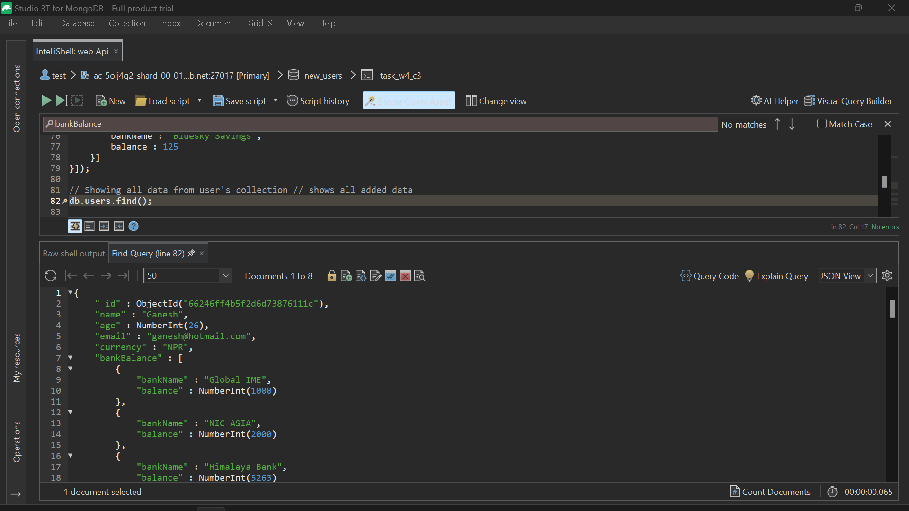

1. Find documents where the age is between 25 and 30:

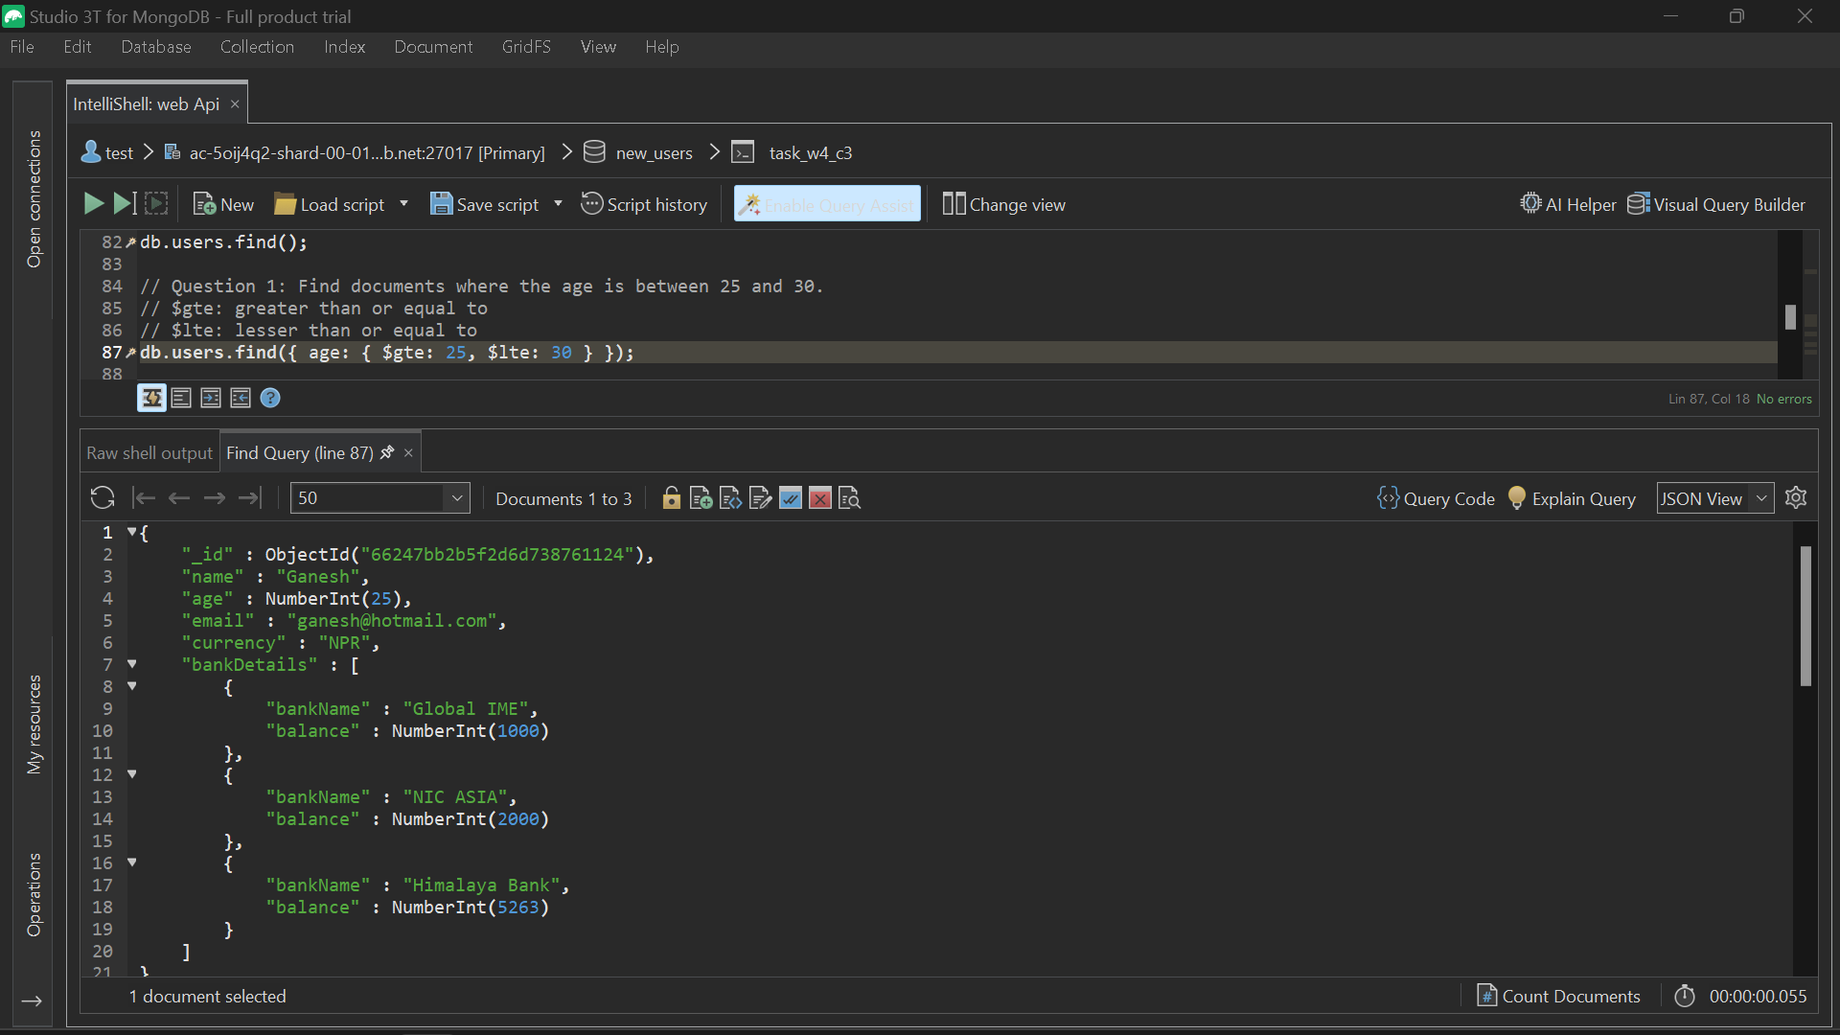

1. Find all users with a bank balance > 500 in any bank.

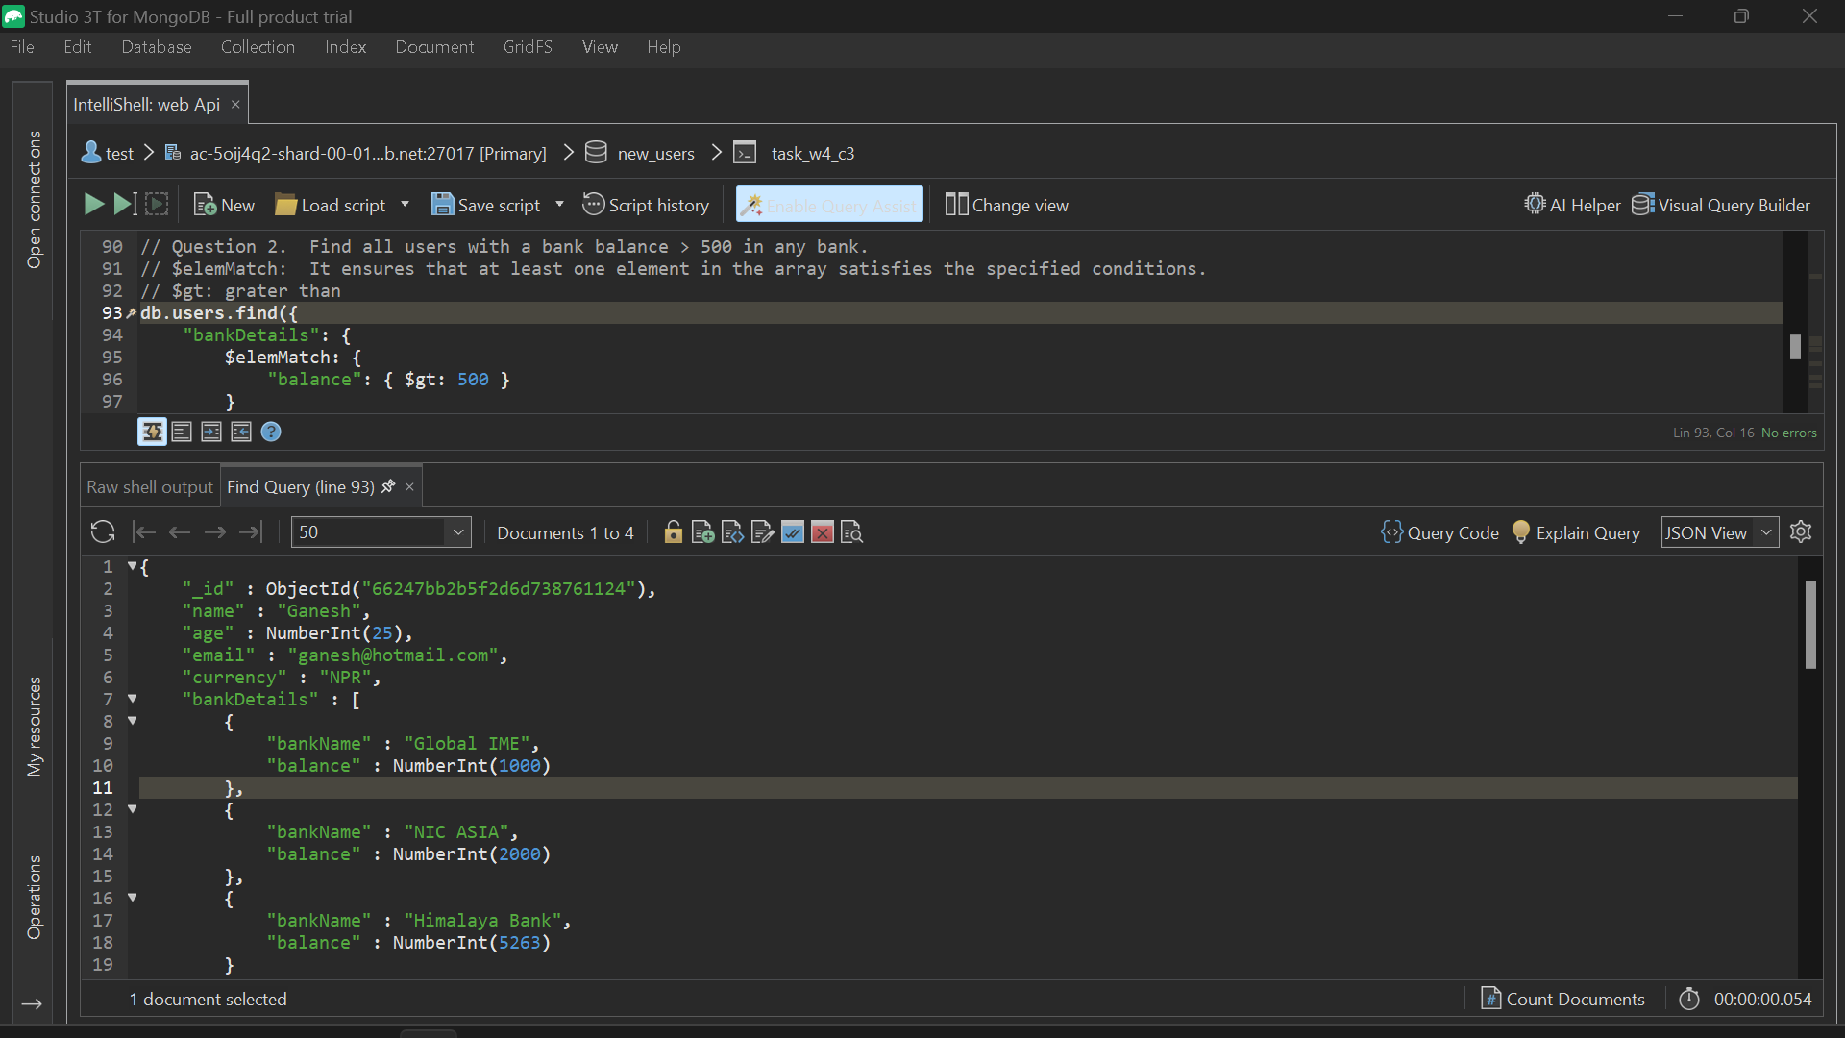

1. Update Ganesh's age to 26

1. Add new bank for Helen (California State Bank, 9K)

1. Rename California Bank to California Savings.

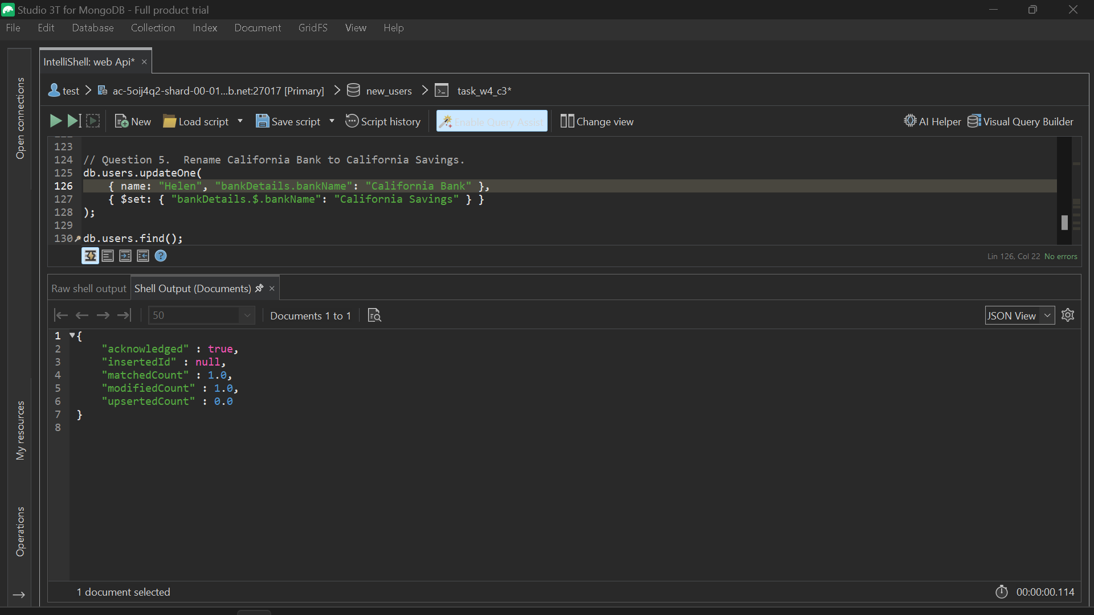

1. Find documents with only the name and email fields included in the result:

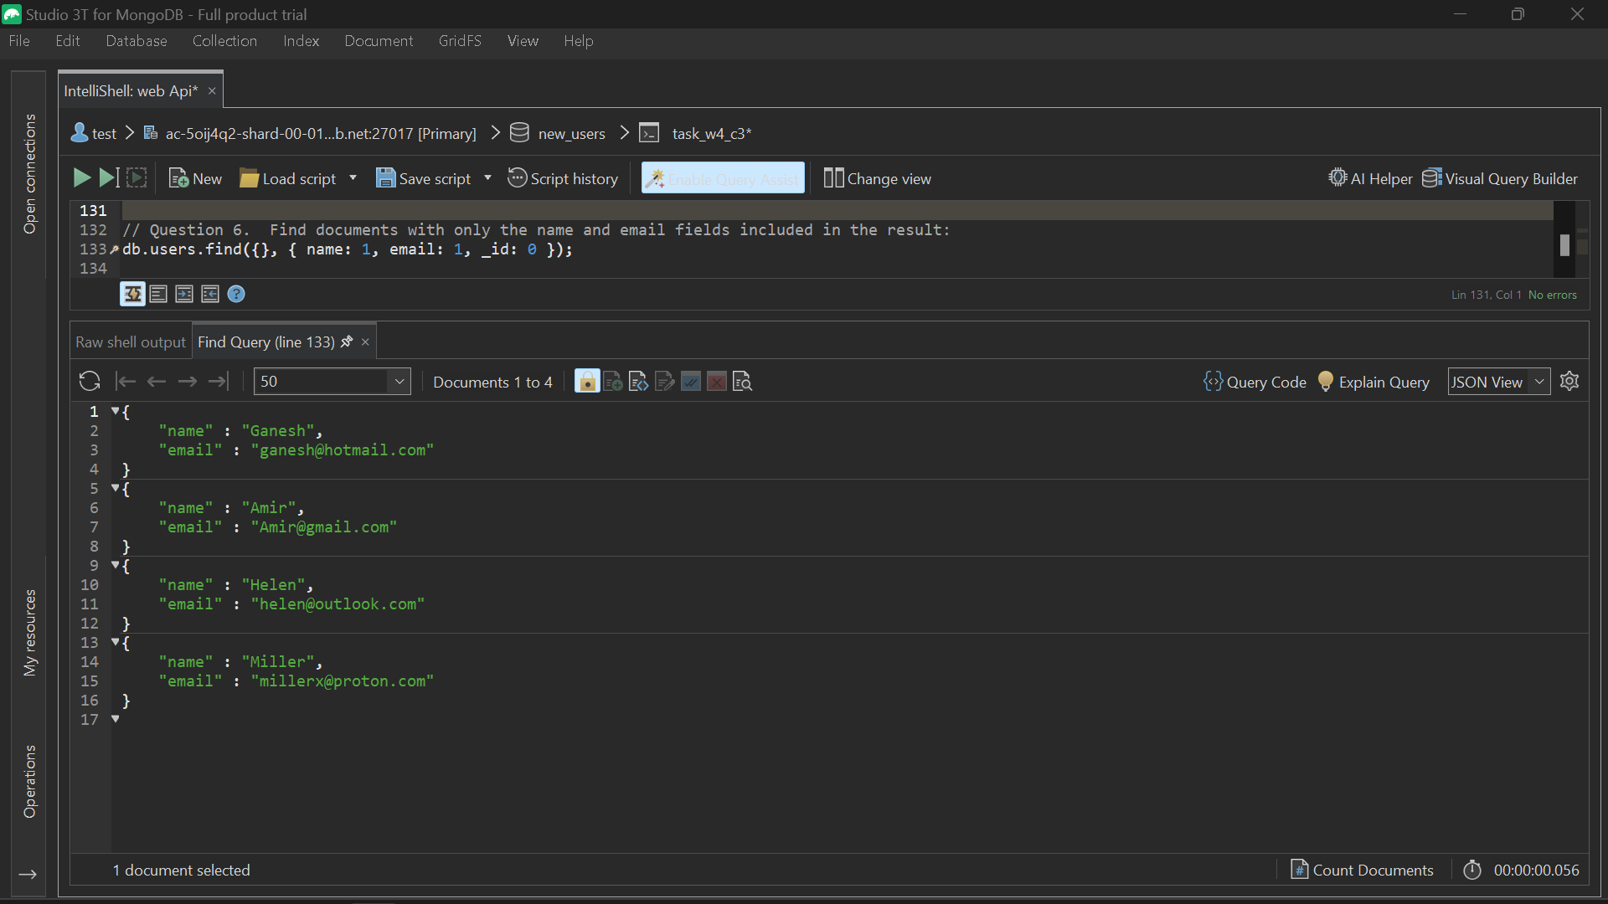

1. Find the total number of documents in the collection:
2. Find the user with the highest bank balance:

